MONEY TRACKER
A PROJECT REPORT
Submitted by
MOHAMED ASHWAQ Y
(2415011113)
in partial fulfilment of the End Semester Examination for the course
CB23F35 – LOW-CODE APPLICATION DEVELOPMENT USING ZOHO CREATOR
BACHELOR OF TECHNOLOGY
ARTIFICIAL INTELLIGENCE AND MACHINE LEARNING

RAJALAKSHMI ENGINEERING COLLEGE
(An Autonomous Institution, Affiliated to Anna University, Chennai)
Rajalakshmi Nagar, Thandalam, Tamil Nadu – 602 105
OCTOBER 2026

BONAFIDE CERTIFICATE
Certified that this project report titled “MONEY TRACKER” is the bonafide work of MOHAMED ASHWAQ Y (2415011113), who carried out the individual project work on Zoho Creator for CB23F35 – Low-Code Application Development using Zoho Creator, during academic year 2026–2027, Semester V, under supervision.
Head of Department: Dr. M. Ayyadurai, M.E., Ph.D.
Course Faculty: Mrs. M. Priya, M.E., Assistant Professor
SIGNATURE OF HoD SIGNATURE OF COURSE FACULTY
Examination date: [To be entered by college]
INTERNAL EXAMINER EXTERNAL EXAMINER

DECLARATION
I, MOHAMED ASHWAQ Y (2415011113), hereby declare that the project report titled “MONEY TRACKER”, submitted for the End Semester Examination of CB23F35, describes my individual Zoho Creator project work. Any templates, sample logic, or AI-assisted materials used must be acknowledged according to college requirements.
Place: Chennai Date: [To be entered]
SIGNATURE OF STUDENT
MOHAMED ASHWAQ Y (2415011113)

ACKNOWLEDGEMENT
I express my sincere gratitude to our Chairman, Mr. S. Meganathan, B.E., F.I.E., and Chairperson, Dr. Mrs. Thangam Meganathan, M.A., M.Phil., Ph.D., for providing the infrastructure and facilities that made this project possible.
I am grateful to our Principal, Dr. S.N. Murugesan, M.E., Ph.D., for the constant encouragement extended to students to undertake industry-relevant learning and practical projects.
I extend my heartfelt thanks to Dr. M. Ayyadurai, M.E., Ph.D., Head of the Department of Artificial Intelligence and Machine Learning, for his valuable guidance, encouragement, and support throughout the course.
I owe my sincere thanks to my course faculty, Mrs. M. Priya, M.E., Assistant Professor, for her valuable guidance, constructive reviews, and feedback that contributed significantly to the development of the MONEY TRACKER application and preparation of this report.
I also acknowledge Zoho Corporation and Zoho Creator for providing access to the platform and its learning resources, which facilitated the development of this application.
Finally, I express my heartfelt gratitude to my family and friends for their continuous encouragement, understanding, and unwavering support throughout the completion of this project.
MOHAMED ASHWAQ Y

ABSTRACT
Personal financial tracking is often fragmented across cash notes, transaction alerts and manually maintained records. MONEY TRACKER, built in Zoho Creator under the application name Expense Ledger System, demonstrates a low-code approach to maintaining transactions, account balances, adjustments and purpose categories. Users can enter debit or credit transactions and consult a central dashboard; auxiliary forms support structured voice-command text and SMS transaction data. Six forms, twelve visible report entries, ten workflow configurations and one dashboard page were observed in the supplied application screenshots. Deluge scripts perform opening-balance initialization, transaction-based credit/debit updates, balance history updates, notifications and deletion-related balance reversals. Two Blueprint designs model verification and transaction-processing review routes. The Dashboard combines summary cards, input shortcuts, visual breakdowns and a transaction report. Multiple-user access and SMS integration have been configured but were not verified end to end; voice commands are entered as text, and demonstrated testing was limited to basic form submissions and dashboard checks. The application is accessible in Zoho Creator, but evidence of formal production release and measured performance improvements has not been supplied. This report therefore distinguishes witnessed interface/code configuration from functionality requiring validation. It documents the data model, workflows, visible screenshots, security considerations, preliminary testing and future improvements, with particular attention to transaction deletion logic and multiuser data isolation.
Keywords: Zoho Creator; Low-Code; Personal Finance; Deluge; Expense Ledger; Workflow Automation.

PROJECT AT A GLANCE
Attribute | Details
Project | MONEY TRACKER
Application domain | Personal financial management
Student | Mohamed Ashwaq Y – 2415011113
Platform edition | Zoho Creator Education (user reported)
Application name | Expense Ledger System
Application link | https://creatorapp.zoho.in/mohamedashwaq.y.2024.aiml518/expense-ledger-system#Section_1
Forms / subforms | 6 forms; subform count not established
Reports | 12 visible entries, including duplicated labels
Pages | 1 Dashboard
Workflows | 10 listed: 2 Blueprints and 8 other automation configurations
Users | Multiple-user access configured, untested
Integrations | SMS integration configured, not verified; email notification Deluge visible
Environment | Application accessible in Zoho Creator; production status not verified
Deployment date | Not verified

TABLE OF CONTENTS
Chapter 1: INTRODUCTION
Chapter 2: LITERATURE SURVEY AND SYSTEM STUDY
Chapter 3: REQUIREMENT ANALYSIS
Chapter 4: SYSTEM DESIGN
Chapter 5: IMPLEMENTATION
Chapter 6: TESTING AND DEBUGGING
Chapter 7: DEPLOYMENT, SECURITY AND GOVERNANCE
Chapter 8: RESULTS AND DISCUSSION
Chapter 9: CONCLUSION AND FUTURE ENHANCEMENTS
References
Appendix A – Feature Coverage Checklist
Appendix B – Course Outcome Mapping
Appendix C – Deluge Code and Screenshot Evidence
Appendix D – User Manual
Appendix E – Evaluation Rubric
Appendix F – Viva-Voce Record Sheet

CHAPTER 1
INTRODUCTION

1.1 Background
Small personal spending decisions can be difficult to reconcile when cash, digital payment and account information are spread across multiple records. A single ledger helps users record sources, transaction amounts and balances and review changes over time.

1.2 Problem Statement
Users need a practical way to capture debit and credit transactions, organize spending purposes, reconcile balances and review financial activity without maintaining disconnected records.
- Manual entries can be inconsistent or omitted.
- Balances can diverge from transaction history.
- Reviewing payments by category or channel is time consuming.
- Imported or parsed messages require validation before their contents are trusted.

1.3 Objectives
- Provide structured entry of financial transactions and account balances.
- Automate updates to account balances using Deluge.
- Support account adjustment and verification workflows.
- Present ledger summaries, charts and report views.
- Offer text-based command and SMS-processing fields with review statuses.

1.4 Scope
In scope: six forms, visible reports, dashboard, observed Deluge rules and two Blueprint configurations. Out of scope or unverified: live bank connections, end-to-end SMS receipt, audio speech recognition, granular user isolation, load performance and full production release.

1.5 Justification for Low-Code
Zoho Creator provides a unified managed platform for forms, reports, pages, workflows and Deluge logic, enabling a student to prototype data capture and automation without implementing independent hosting and CRUD infrastructure.

1.6 Organisation
Chapters 2–9 document related solutions, requirements, design, implementation, testing, deployment, results and future enhancements.

CHAPTER 2
LITERATURE SURVEY AND SYSTEM STUDY

2.1 Existing System
A typical manual approach records expenses in notebooks, phone notes or spreadsheets and periodically reconciles account totals.

2.2 Limitations
- Scattered data sources
- Repeated manual reconciliation
- Difficult error tracing and filtering
- Limited integrated review workflow

2.3 Low-Code versus Traditional Development
Criteria | Traditional development | Zoho Creator
Setup | Custom database, UI and hosting | Integrated forms, reports and application hosting
Automation | Write and deploy independent services | Built-in event rules and Deluge
Maintenance | Separate infrastructure changes | Application builder edits
Constraints | High custom flexibility | Dependent on platform limits and supported API

2.4 Literature Survey
Reference material comprises official product documentation and representative personal finance software. No externally verified research-paper comparison was provided; formal academic citations should be completed before submission.
Source | Relevance
Zoho Creator documentation [1] | Form, report, page and workflow concepts
Zoho Deluge documentation [2] | Event-triggered business logic
Zoho Creator security documentation [3] | Permission and sharing concepts
GNUCash documentation [4] | Example of personal ledger accounting principles
Money Manager Ex documentation [5] | Example of income/expense analysis functionality

2.5 Emerging Trends
Low-code visual process automation can accelerate iterative financial tool design; message parsing and AI-assisted classification remain potential future enhancements.

2.6 Proposed System
An application-centered ledger joins transaction entry, account state, review status and dashboard reporting in a single Zoho Creator app.

CHAPTER 3
REQUIREMENT ANALYSIS

3.1 Stakeholders and User Roles
Actor | Responsibilities | Evidence
Owner/creator | Manage app configuration | Observed editor access
Additional users | Submit or view their authorized data | Configured; permission segregation not tested

3.2 Functional Requirements
ID | Requirement | Status
FR-01 | Record debit or credit transaction | Form visible
FR-02 | Maintain opening/current balances | Form and script visible
FR-03 | Organize purpose categories | Form visible
FR-04 | Handle adjustment verification | Blueprint configured
FR-05 | Capture SMS and command text for processing | Forms configured; end-to-end integration untested
FR-06 | Show dashboard and ledger | Dashboard visible
FR-07 | Email admin on processing success | Deluge script visible; delivery untested

3.3 Non-Functional Requirements
Category | Requirement | Validation state
Security | Prevent unauthorized account disclosure | Not tested
Correctness | Credit/debit and delete reversals reconcile | Partial code inspection; bug suspected
Usability | Accessible on browser with clear navigation | Screenshot evidence
Reliability | Error status and retry handling | Blueprint design present; not end-to-end tested
Performance | Responsive dashboard for target data volume | No benchmark available

3.4 Hardware and Software
Zoho Creator Education (reported), Zoho Deluge, desktop web browser, network connectivity. Screenshot environment depicts Chrome on Windows.

3.5 Use Case Model
Primary use cases: add transaction → update balance → review report; configure account → initialize opening balance; submit command/SMS text → parse/review → potentially create transaction. Final processing path not verified.

CHAPTER 4
SYSTEM DESIGN

4.1 Architecture
Browser / configured Zoho users → Zoho Creator navigation and forms → Deluge event rules and Blueprint transitions → Creator records and report views → Dashboard. SMS connection is configured, but transport and payload details were not provided.

4.2 Data Model
Core entities: Transaction, Account Balance, Balance Adjustment, Purpose Category, Voice Entry and SMS Inbox. Visible selection controls indicate candidate references linking transactions to accounts and parsed entries to linked transactions. Exact lookup cardinalities require builder verification.
Entity | Principal attributes | Relations visible or inferred
Transaction | Type, amount, mode, purpose, date, balance after | Account Reference selection
Account Balance | Account Type, opening/current balance, verification status | Referenced by transactions
Balance Adjustment | Account Type, new balance, difference, linked transaction | Linked transaction selection
Purpose Category | Category Name, keywords, priority, usage | Linked Transactions field
Voice Entry | Command Text, parsed amount, mode, status | Linked Transaction selection
SMS Inbox | SMS Text, sender, parsed type, status | Linked Transaction selection

4.3 Form Design

Field specification – Transaction
Field label | Interface notes
Transaction Id | Visible; exact link name and validation not fully verified
Transaction Type | Visible; exact link name and validation not fully verified
Amount | Visible; exact link name and validation not fully verified
Payment Mode | Visible; exact link name and validation not fully verified
Purpose | Visible; exact link name and validation not fully verified
Description | Visible; exact link name and validation not fully verified
Transaction Date | Visible; exact link name and validation not fully verified
Source | Visible; exact link name and validation not fully verified
Raw Text | Visible; exact link name and validation not fully verified
Balance After | Visible; exact link name and validation not fully verified
Needs Review | Visible; exact link name and validation not fully verified
Split Items | Visible; exact link name and validation not fully verified
Account Reference | Visible; exact link name and validation not fully verified
Created Date | Visible; exact link name and validation not fully verified
Last Modified Date | Visible; exact link name and validation not fully verified

Field specification – Voice Entry
Field label | Interface notes
Command Text | Visible; exact link name and validation not fully verified
Parsed Amount | Visible; exact link name and validation not fully verified
Parsed Mode | Visible; exact link name and validation not fully verified
Parsed Type | Visible; exact link name and validation not fully verified
Detected Purpose | Visible; exact link name and validation not fully verified
Is Processed | Visible; exact link name and validation not fully verified
Created Date | Visible; exact link name and validation not fully verified
Processing Status | Visible; exact link name and validation not fully verified
Error Message | Visible; exact link name and validation not fully verified
Linked Transaction | Visible; exact link name and validation not fully verified

Field specification – Balance Adjustment
Field label | Interface notes
Account Type | Visible; exact link name and validation not fully verified
New Balance | Visible; exact link name and validation not fully verified
Reason | Visible; exact link name and validation not fully verified
Difference Amount | Visible; exact link name and validation not fully verified
Adjustment Type | Visible; exact link name and validation not fully verified
Is Processed | Visible; exact link name and validation not fully verified
Created Date | Visible; exact link name and validation not fully verified
Processed Date | Visible; exact link name and validation not fully verified
Linked Transaction | Visible; exact link name and validation not fully verified
Notes | Visible; exact link name and validation not fully verified
Verification Status | Visible; exact link name and validation not fully verified

Field specification – Purpose Category
Field label | Interface notes
Category Name | Visible; exact link name and validation not fully verified
Keywords | Visible; exact link name and validation not fully verified
Default Allocation | Visible; exact link name and validation not fully verified
Is Active | Visible; exact link name and validation not fully verified
Created Date | Visible; exact link name and validation not fully verified
Last Modified Date | Visible; exact link name and validation not fully verified
Usage Count | Visible; exact link name and validation not fully verified
Priority Level | Visible; exact link name and validation not fully verified
Notes | Visible; exact link name and validation not fully verified
Linked Transactions | Visible; exact link name and validation not fully verified

Field specification – SMS Inbox
Field label | Interface notes
SMS Text | Visible; exact link name and validation not fully verified
Sender | Visible; exact link name and validation not fully verified
Received On | Visible; exact link name and validation not fully verified
Is Processed | Visible; exact link name and validation not fully verified
Parsed Amount | Visible; exact link name and validation not fully verified
Parsed Mode | Visible; exact link name and validation not fully verified
Parsed Type | Visible; exact link name and validation not fully verified
Detected Purpose | Visible; exact link name and validation not fully verified
Created Date | Visible; exact link name and validation not fully verified
Processing Status | Visible; exact link name and validation not fully verified
Error Message | Visible; exact link name and validation not fully verified
Linked Transaction | Visible; exact link name and validation not fully verified

Field specification – Account Balance
Field label | Interface notes
Account Type | Visible; exact link name and validation not fully verified
Opening Balance | Visible; exact link name and validation not fully verified
Current Balance | Visible; exact link name and validation not fully verified
Last Updated | Visible; exact link name and validation not fully verified
Is Active | Visible; exact link name and validation not fully verified
Notes | Visible; exact link name and validation not fully verified
Created Date | Visible; exact link name and validation not fully verified
Last Modified Date | Visible; exact link name and validation not fully verified
Balance History | Visible; exact link name and validation not fully verified
Verification Status | Visible; exact link name and validation not fully verified

4.4 Workflow Design
Two Blueprints were supplied: balance verification and adjustment, and voice/SMS transaction processing. The former models review, approval, adjustment and fallback; the latter models parse, manual review, validation, linked transaction creation and abort/failure paths.

4.5 Navigation
The left navigation has Dashboard, Transactions, Voice Entries, Balance Adjustments, Purpose Categories, SMS Inbox and Account Balances.

4.6 Access Control
Multiple-user access is reported as configured, but role-specific record permissions and isolation have not been verified; a role–permission matrix cannot honestly be presented as implemented.

CHAPTER 5
IMPLEMENTATION

5.1 Application Setup
Application name: Expense Ledger System. Project report title: MONEY TRACKER. Built in Zoho Creator Education edition (reported).
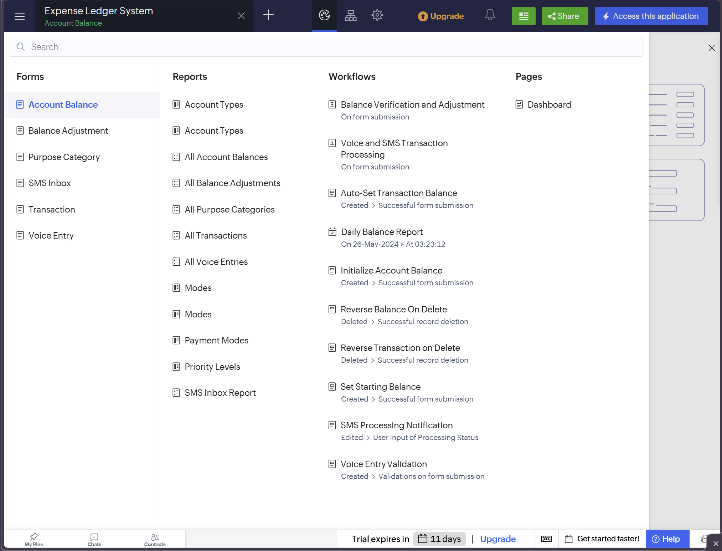
Figure 5.1: Zoho Creator component inventory – forms, reports, workflows and page

5.2 Forms and Data Capture
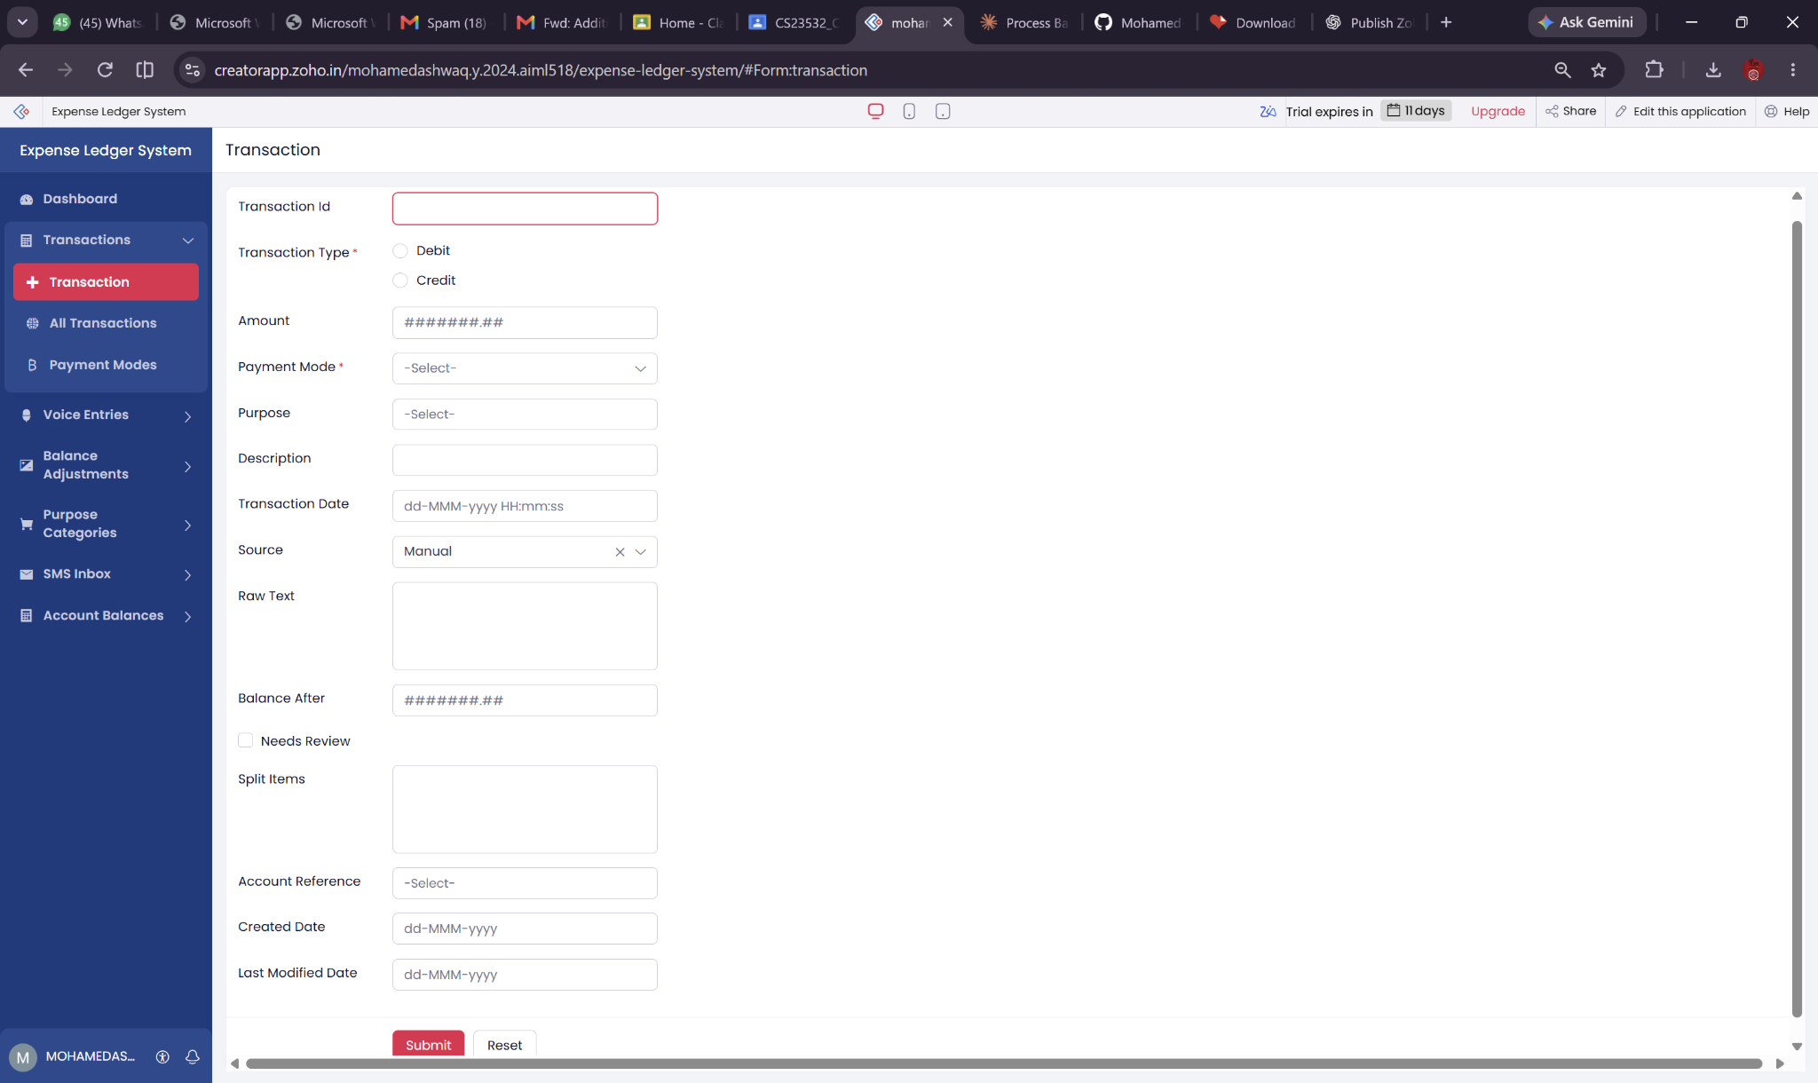
Figure 5.2: Transaction live form
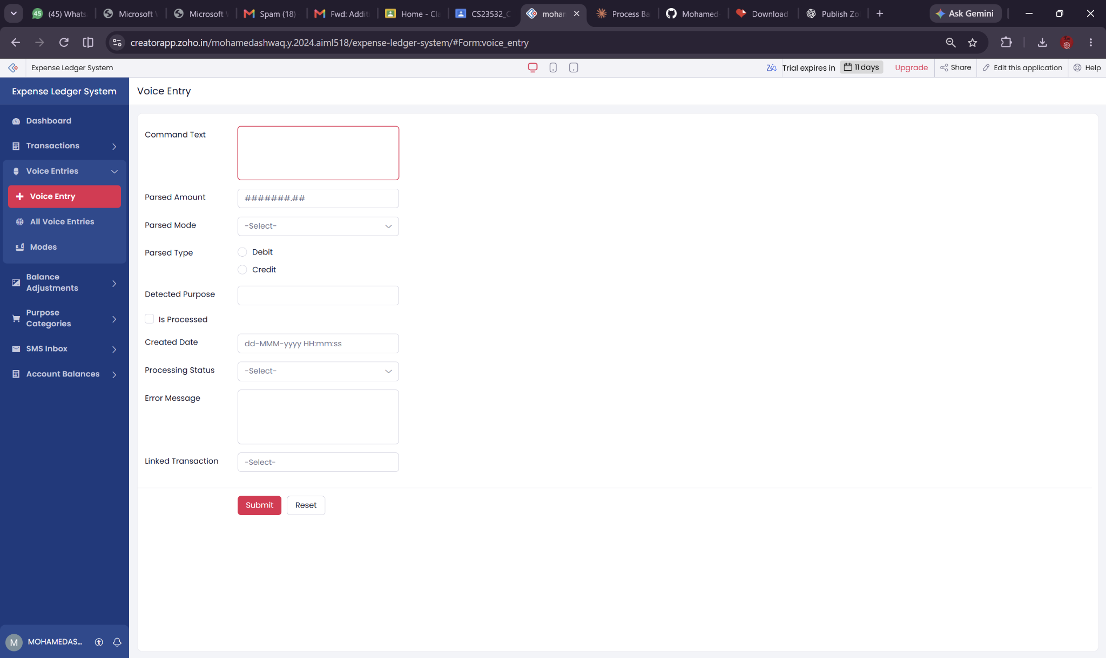
Figure 5.2: Voice Entry live form
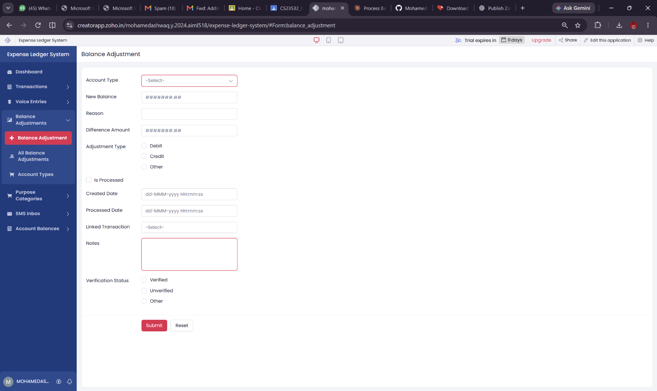
Figure 5.2: Balance Adjustment live form
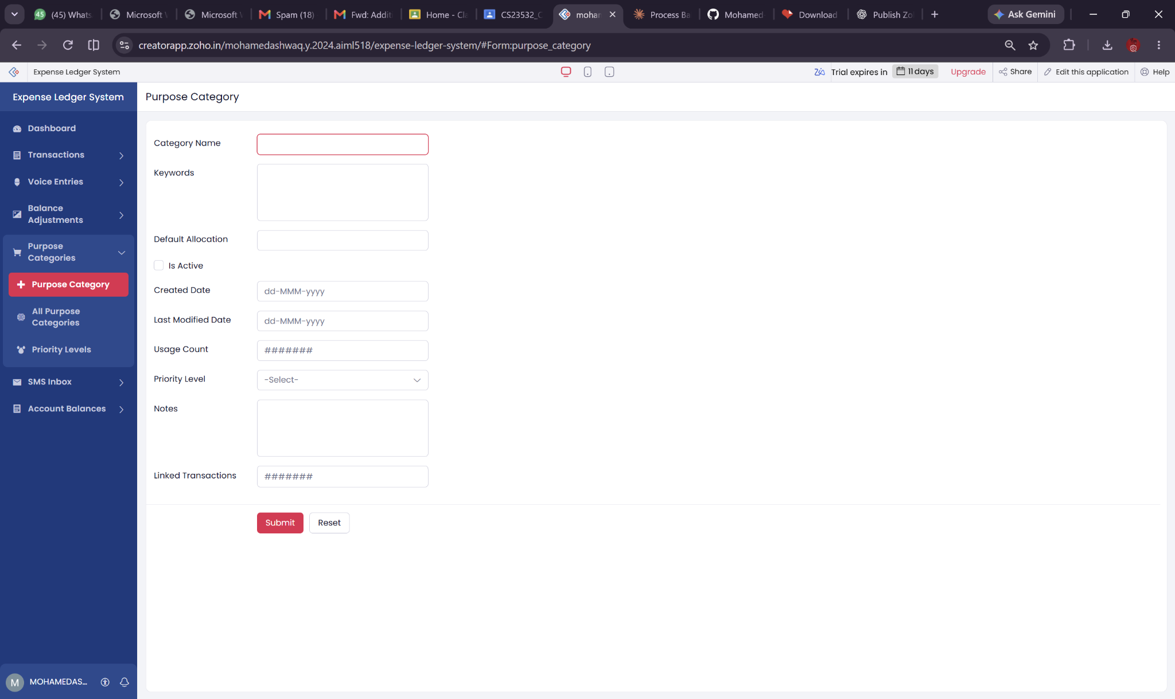
Figure 5.2: Purpose Category live form
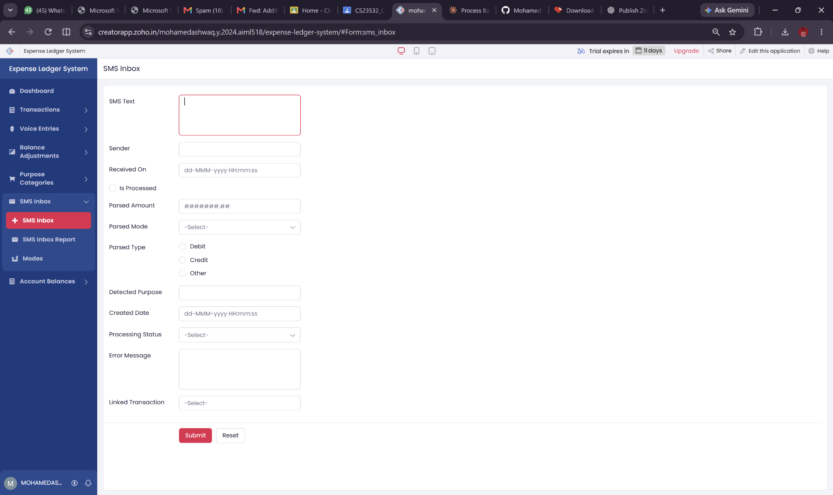
Figure 5.2: SMS Inbox live form
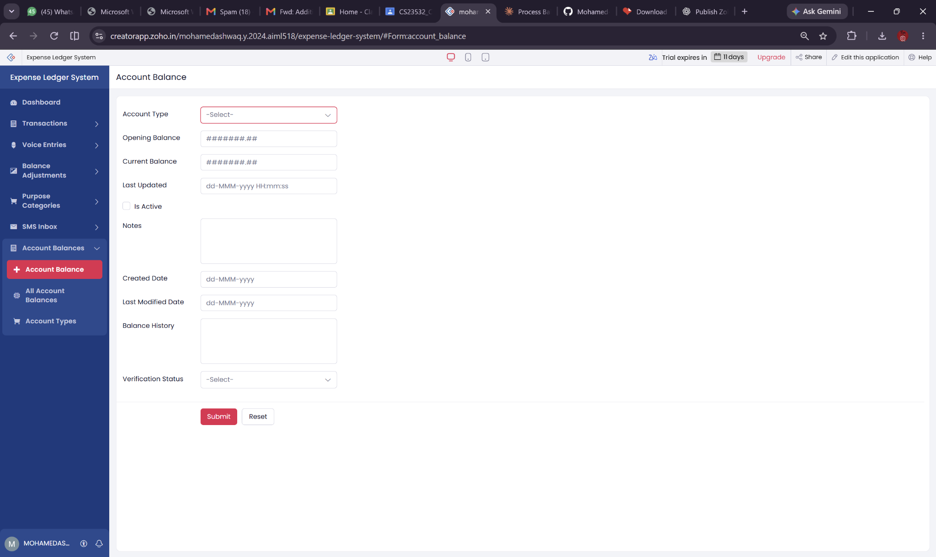
Figure 5.2: Account Balance live form

5.3 Reports
Twelve report entries are visible: Account Types (twice), All Account Balances, All Balance Adjustments, All Purpose Categories, All Transactions, All Voice Entries, Modes (twice), Payment Modes, Priority Levels, and SMS Inbox Report. Names appearing twice are counted as separate navigation entries, not asserted to be unique report types.

5.4 Pages and Dashboard
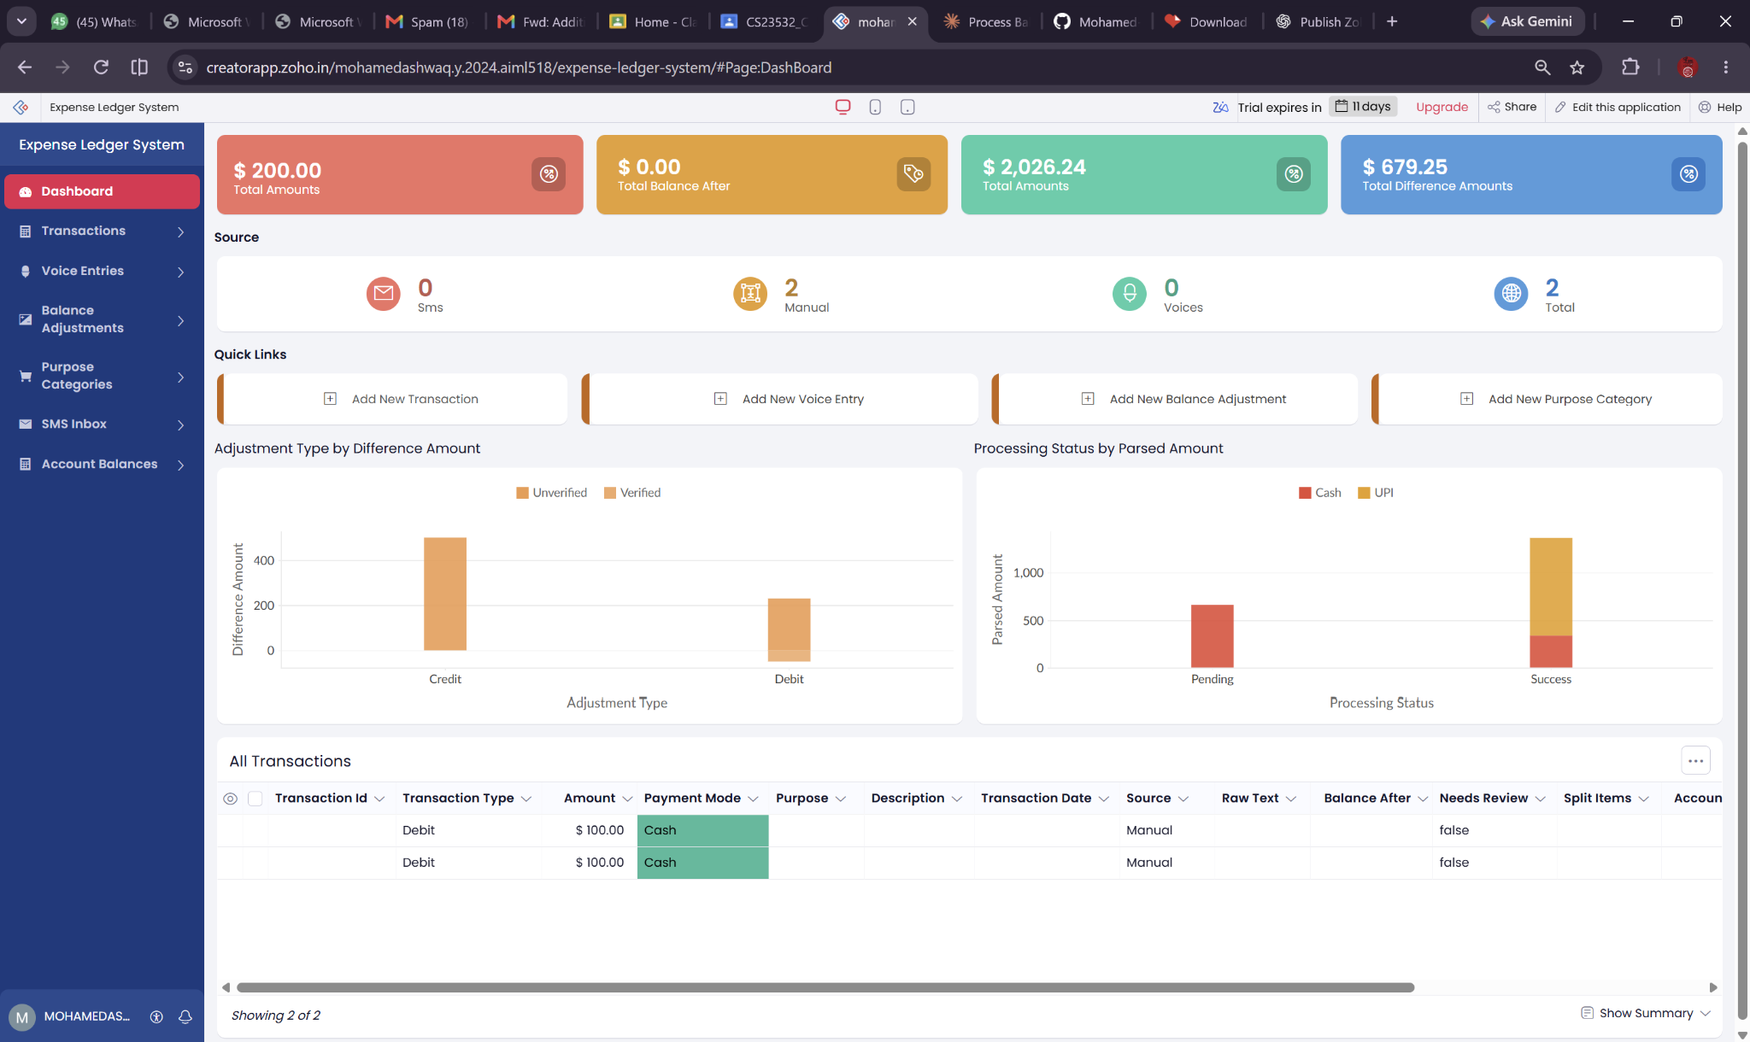
Figure 5.3: MONEY TRACKER live dashboard
Dashboard displays amount/balance summary cards, source counts (SMS, manual, voice), quick-action links, adjustment/processing charts and the embedded All Transactions report. Snapshot includes two manual transactions and no displayed SMS or voice transactions; these are sample interface values rather than measured outcome metrics.

5.5 Deluge Scripting
Script | Observed logic
Auto-Set Transaction Balance | Credit adds amount; debit subtracts; updates account and history
Daily Balance Report | Builds active account balance HTML email to administrator
Initialize Account Balance | Current balance set to opening balance
Set Starting Balance | Similar initialization of current balance
Reverse Balance On Delete | Reverses debit/credit on transaction deletion
Reverse Transaction on Delete | Traverses linked accounts; apparent sign issue requires testing
SMS Processing Notification | Administrator email on status Success
Voice Entry Validation | Cancels empty/failed or missing-status commands

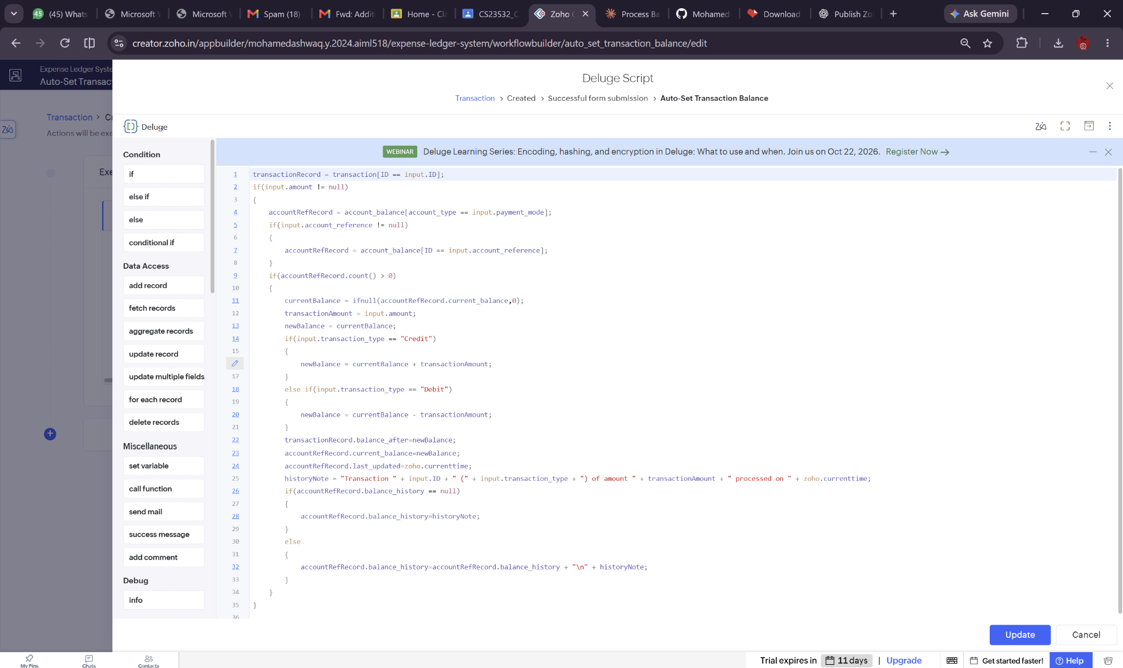
Deluge evidence: Auto-Set Transaction Balance
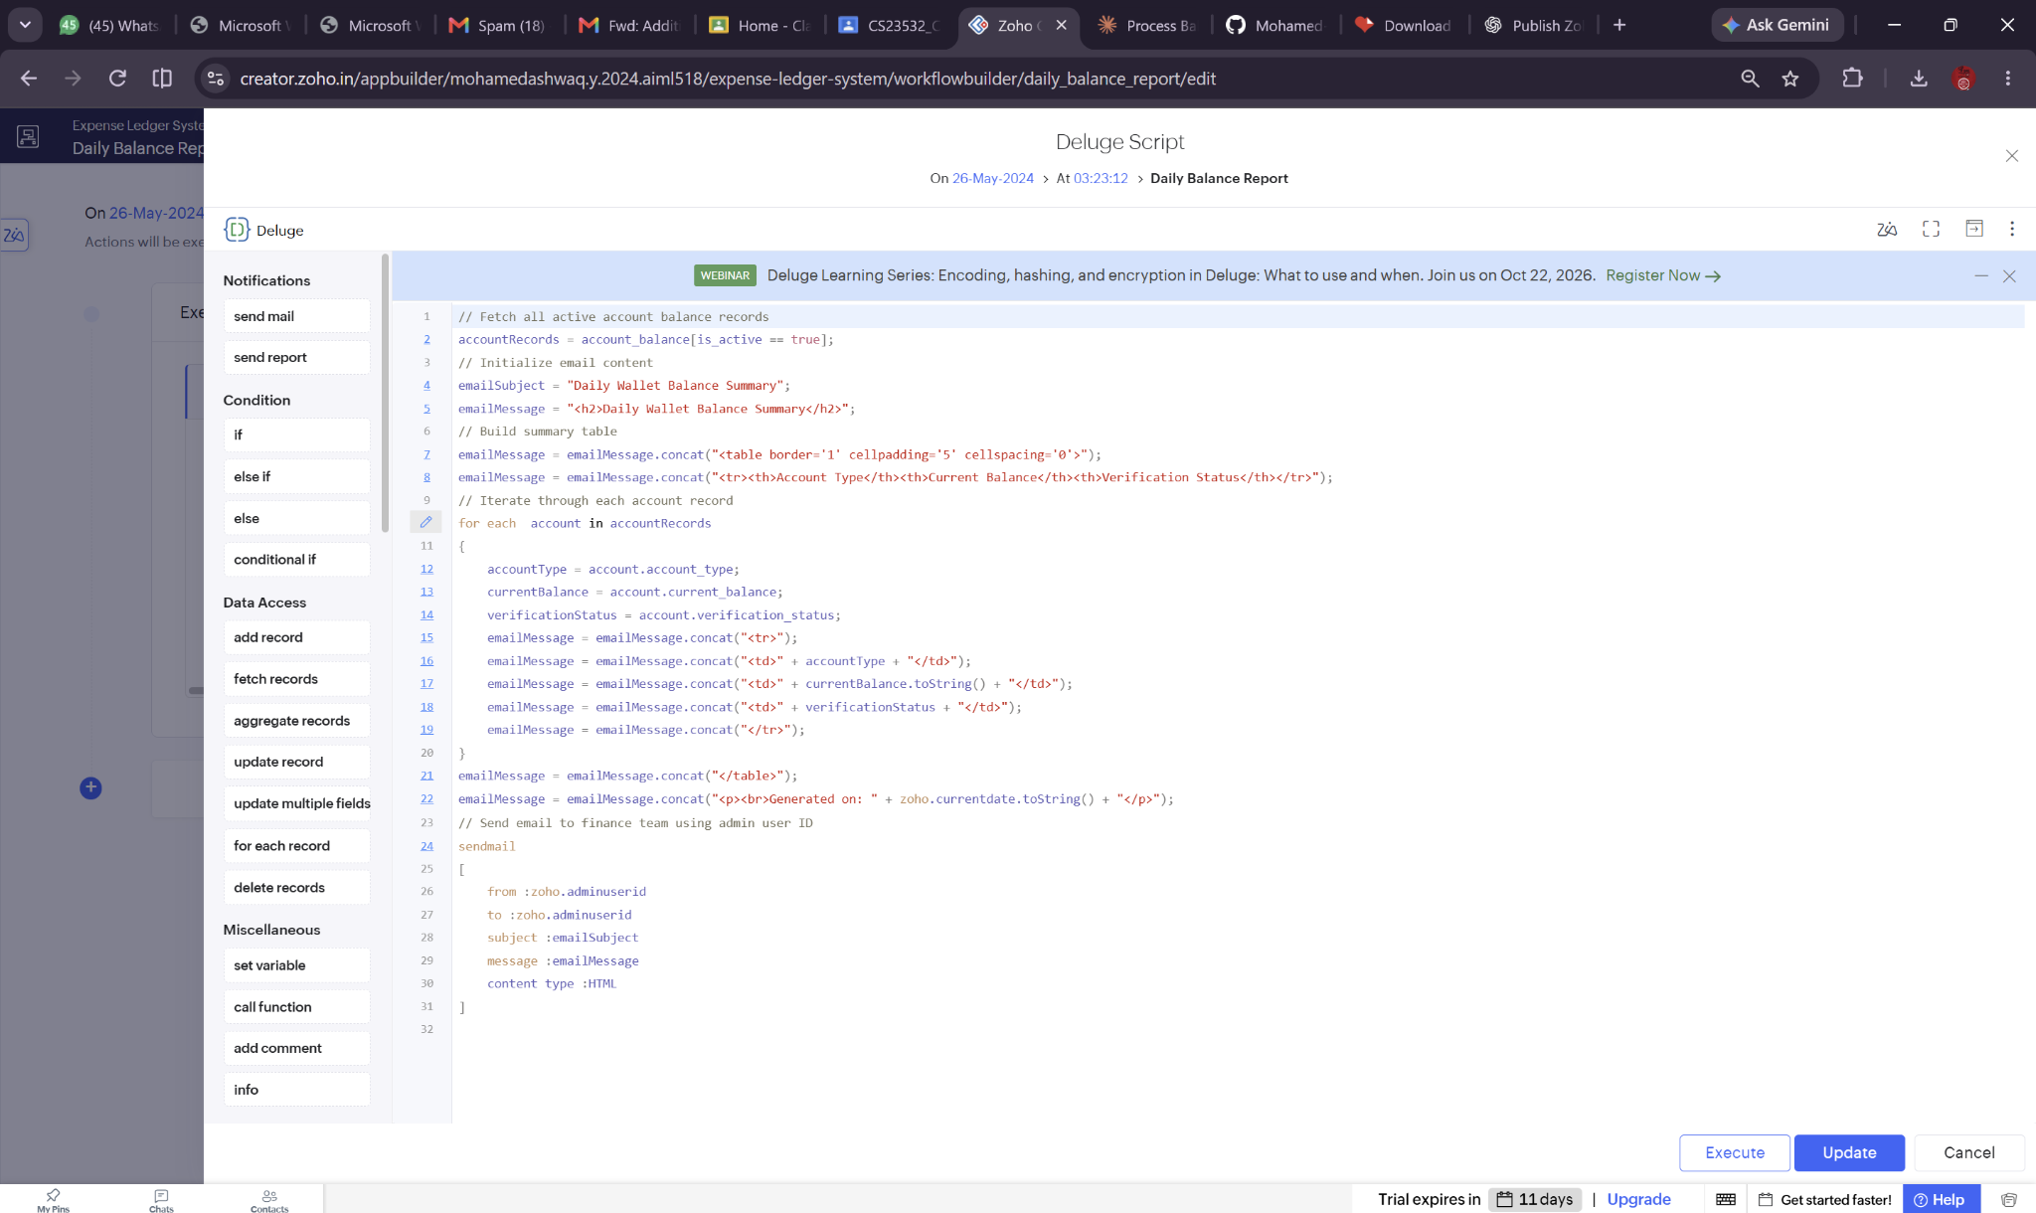
Deluge evidence: Daily Balance Report
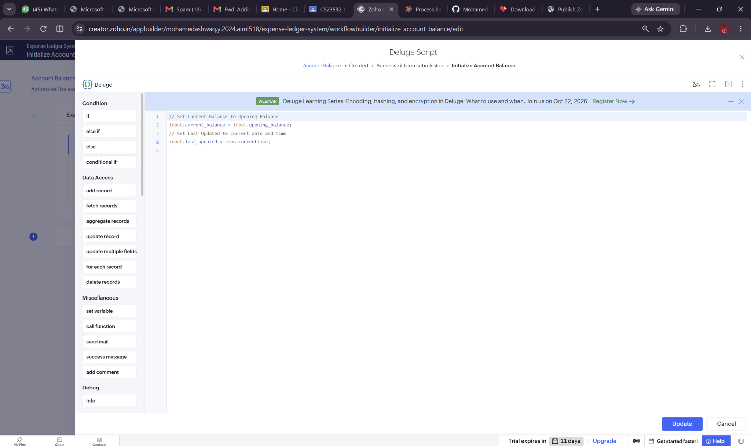
Deluge evidence: Initialize Account Balance
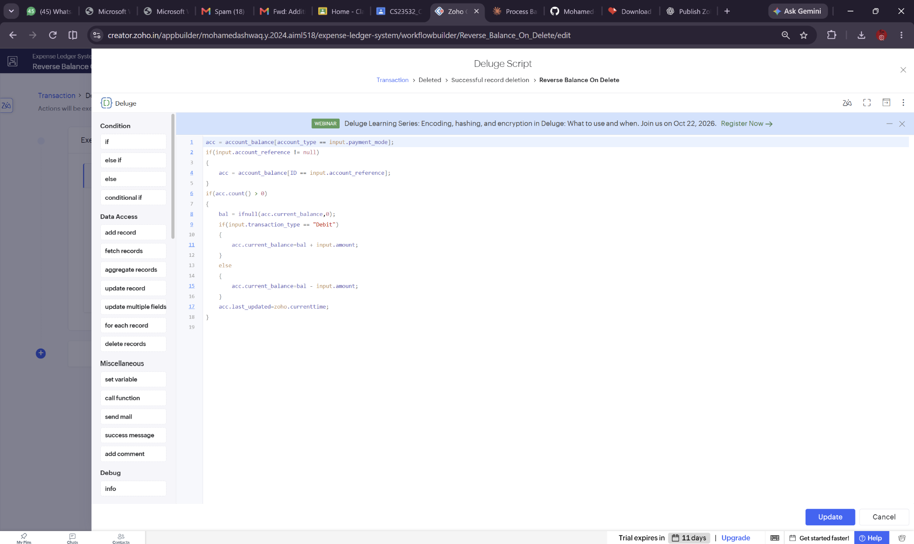
Deluge evidence: Reverse Balance On Delete
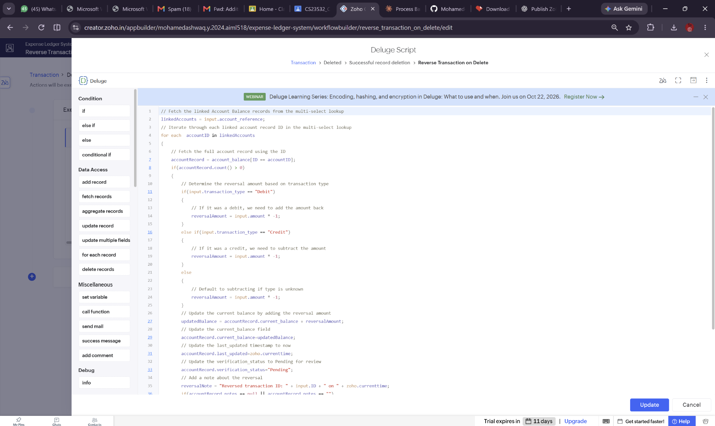
Deluge evidence: Reverse Transaction on Delete – visible excerpt
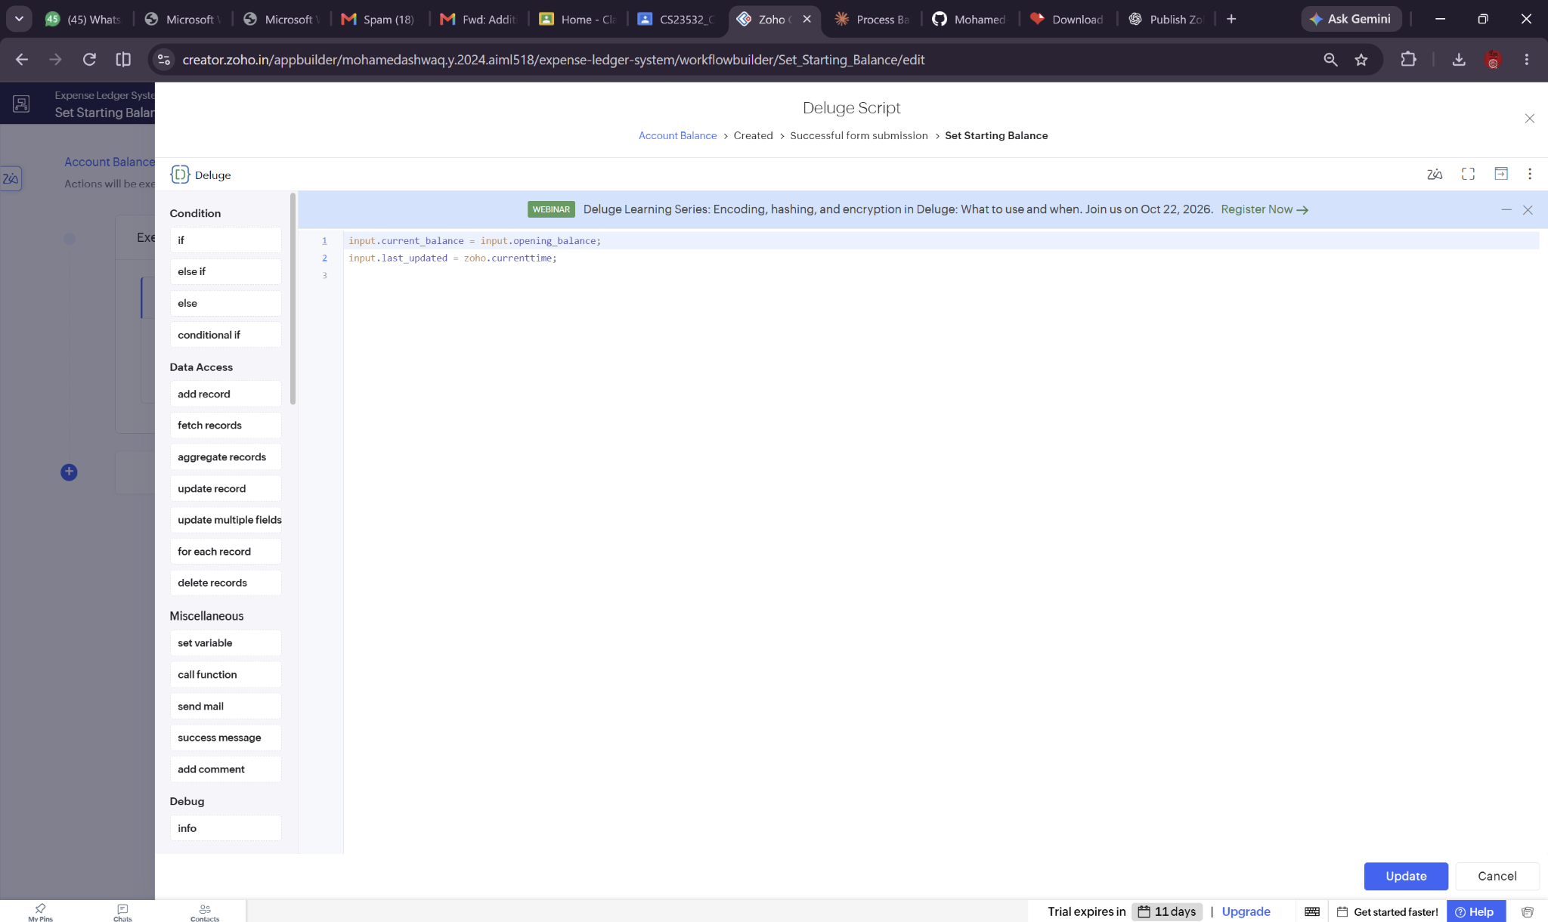
Deluge evidence: Set Starting Balance
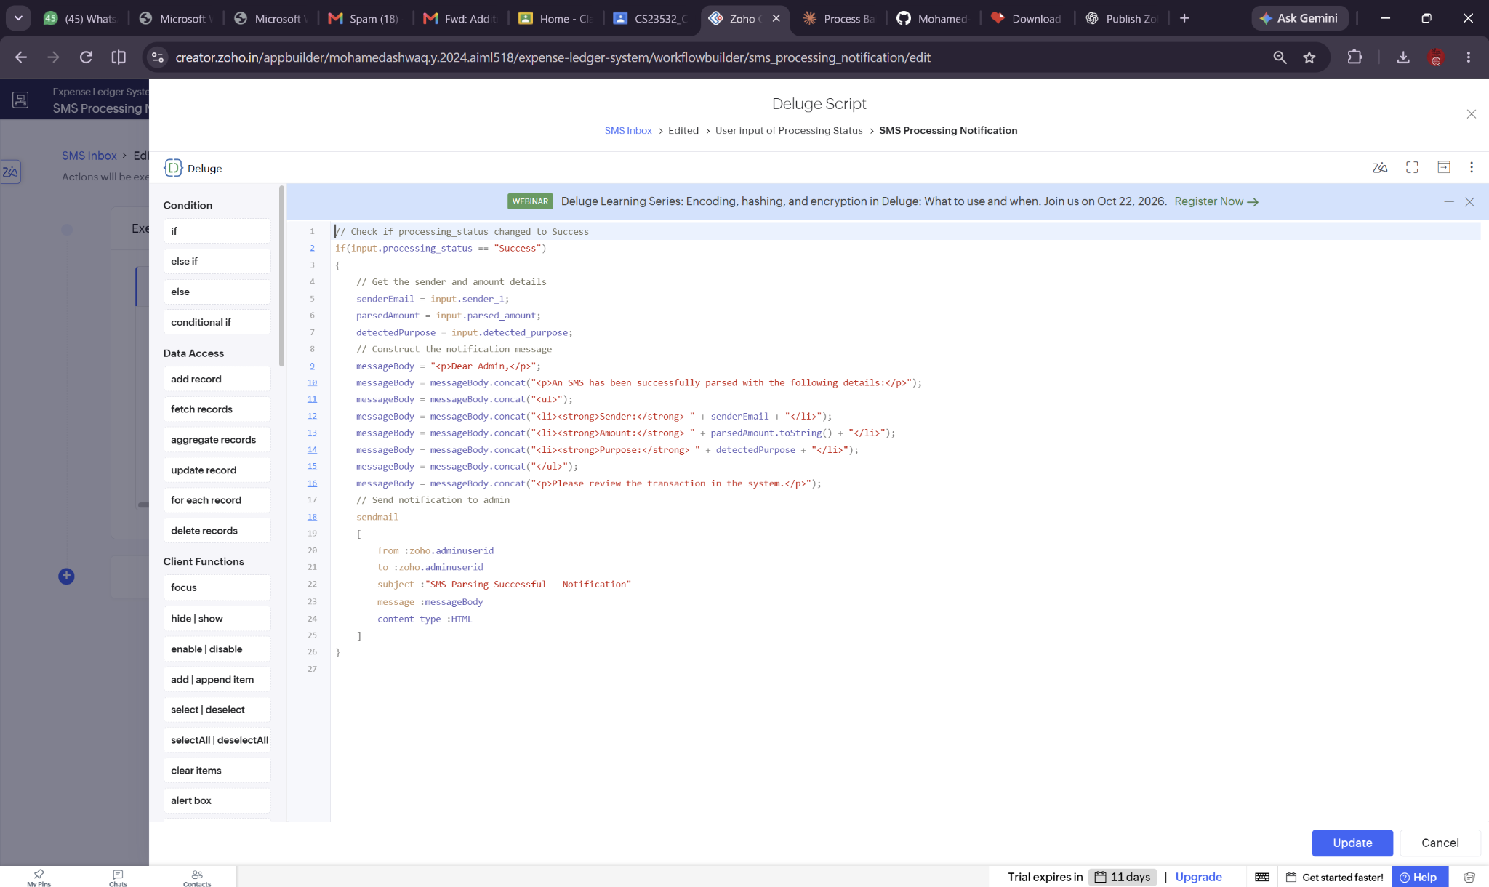
Deluge evidence: SMS Processing Notification
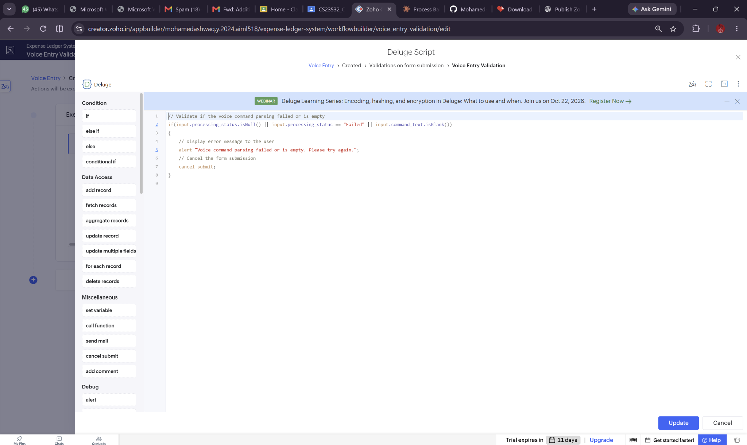
Deluge evidence: Voice Entry Validation

5.6 Workflows and Automation
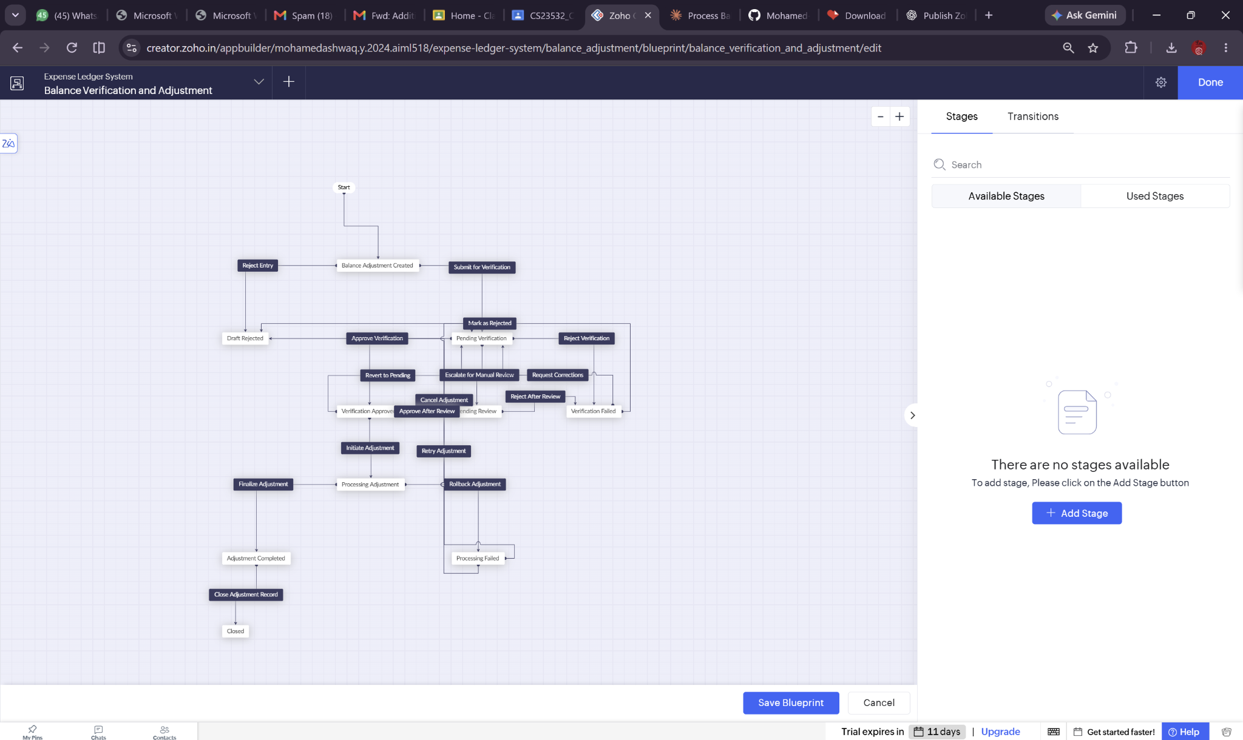
Figure 5.4: Balance Verification and Adjustment Blueprint
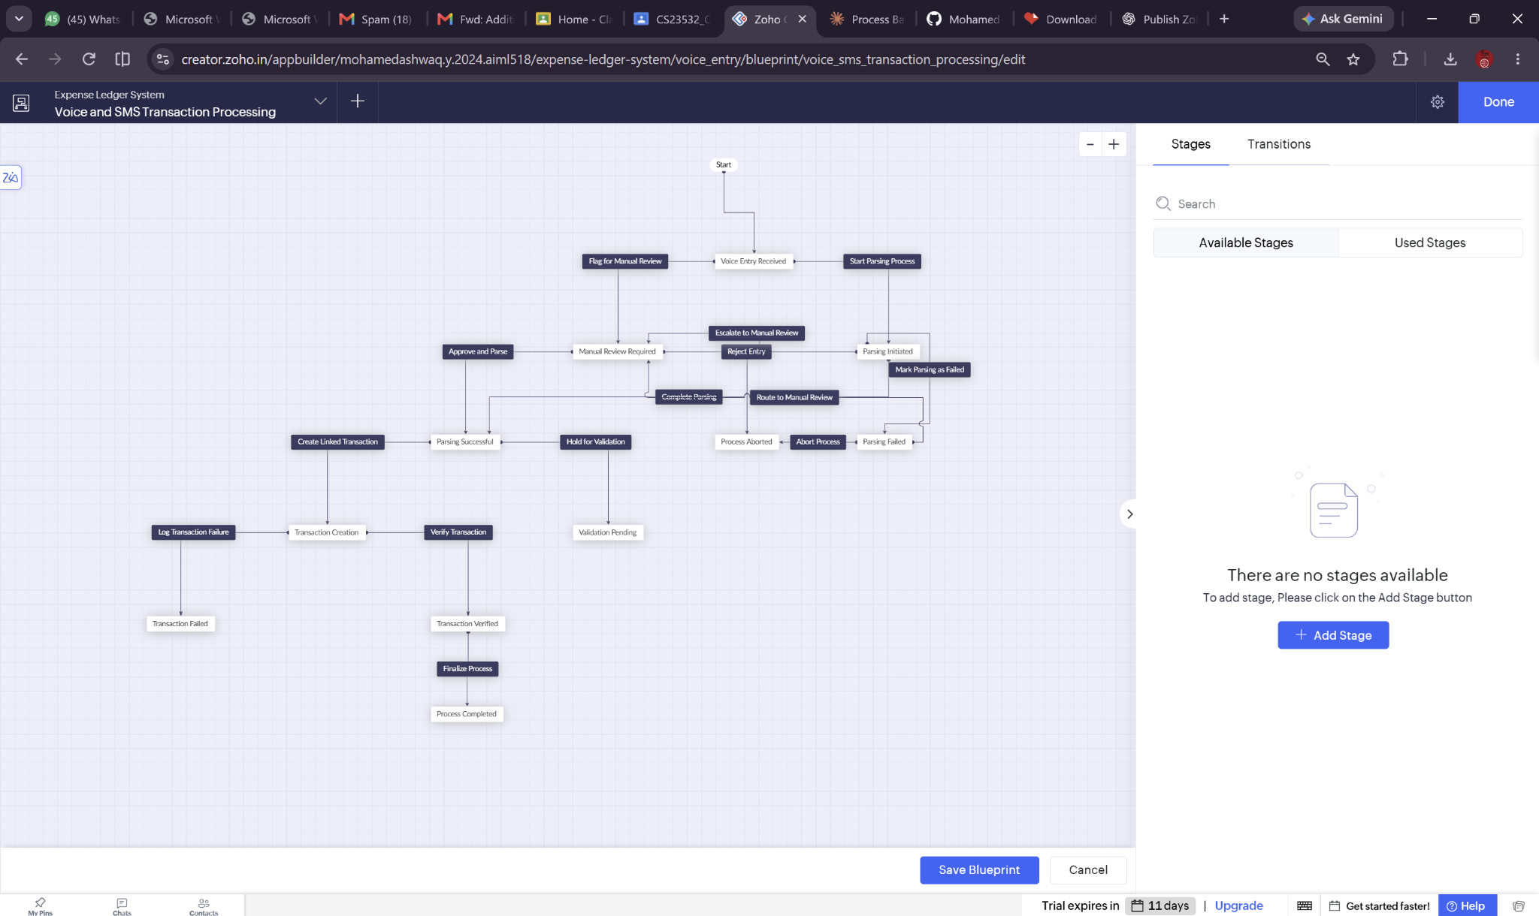
Figure 5.5: Voice and SMS Transaction Processing Blueprint
The two Blueprint diagrams show designed transitions. Their end-to-end runtime behavior and approval roles have not been verified.

5.7 Integrations
SMS integration was configured according to the developer, but no evidence of live reception or API credentials/connection behavior was supplied. HTML email actions are present in Deluge but delivery was not demonstrated.

5.8 Roles
Multiple-user setup exists in configuration, though segregation and per-role permissions remain untested.

5.9 AI and Analytics
Charts on the dashboard are confirmed. AI-based prediction/classification was not demonstrated.

5.10 Pro-Code Extension
Not implemented as a separate pro-code extension; Deluge covers the visible scripted logic.

5.11 Mobile and Portal Access
Browser interface observed; mobile and portal use not demonstrated.

CHAPTER 6
TESTING AND DEBUGGING

6.1 Testing Strategy
The developer confirmed basic form submission and dashboard checks only. The following table distinguishes observed evidence from recommended validation tests; it does not assert unprovided test outcomes.

6.2 Test Cases
ID | Scenario | State
TC-01 | Open transaction and balance forms | UI screenshot verified
TC-02 | View populated Dashboard | Screenshot verified
TC-03 | Debit balance decrement/credit increment | Code inspected; runtime test not evidenced
TC-04 | Delete debit then credit; compare balances | Not verified
TC-05 | Invalid or empty voice command | Validation code visible; runtime test not verified
TC-06 | Automatically receive SMS through integration | Not verified
TC-07 | Cross-user data isolation | Not verified
TC-08 | Email notification delivery | Not verified

6.3 Debugging Deluge
One deletion script screenshot appears to compute a negative reversal amount in both Debit and Credit branches, which may produce an incorrect balance restoration. This needs a controlled test and script correction if confirmed. Multiple scripts also initialize opening balances; their triggering order should be reviewed to prevent duplicated state changes.

6.4 Defect Log
Issue | Status
Potential incorrect credit reversal sign | Suspected from code; not validated
Duplicate initialization workflows | Review needed; not established as defect
SMS integration end-to-end status | Untested
Multiuser access control | Untested

6.5 User Acceptance Testing
No signed UAT records or multiuser testing results were supplied; therefore acceptance is pending.

CHAPTER 7
DEPLOYMENT, SECURITY AND GOVERNANCE

7.1 Environments
Application was shown accessible through the Zoho Creator runtime URL. Formal development-to-stage-to-production promotion and a release date were not evidenced.

7.2 Performance
No measured response times, concurrent-user statistics or load-test results supplied.

7.3 Security Features
Configured multiple-user access requires validation of least privilege and record-level segregation. Sensitive SMS content and financial data should not be sent to unauthorized users. Email actions use administrator identity in the visible scripts.

7.4 Governance
Recommended controls: audit field changes, retain historical adjustment records, limit export privileges and review Deluge configuration before sharing with real users.

CHAPTER 8
RESULTS AND DISCUSSION

8.1 Application Output
The supplied Dashboard demonstrates that the application renders financial summary cards, source counts, visual charts and a transaction listing. Displayed sample amounts are snapshot values, not a benchmark for savings or accuracy.
Figure 8.1: Dashboard output with records and charts

8.2 Objectives
Objective | Observed result
Transaction entry | Live form screenshot
Account reconciliation | Scripts configured; correctness not comprehensively tested
Financial dashboard | Live screenshot
SMS and command workflows | Fields and workflow designs, runtime unverified
Multiuser support | Configured; isolation unverified

8.3 Existing vs Proposed
The proposed application consolidates structured entries and reports. Quantitative reductions in manual effort, errors or turnaround time were not measured.

8.4 Low-Code Limitations
Tight coupling to Zoho Creator facilities, platform-specific scripting and availability of third-party integrations; visual workflow setup does not independently demonstrate correctness.

8.5 Spectrum
Form builders illustrate no-code assembly; Deluge and custom Blueprint logic represent low-code extension. A distinct pro-code extension was not demonstrated.

CHAPTER 9
CONCLUSION AND FUTURE ENHANCEMENTS

9.1 Conclusion
MONEY TRACKER is a documented Zoho Creator personal finance prototype featuring six forms, twelve visible report entries, a dashboard and ten configured workflows. It demonstrates ledger entry and low-code automation design. Claims of SMS automation, multiuser protection, and robust accounting correctness remain subject to verification.

9.2 Future Enhancements
- Complete systematic debit/credit and deletion reversal tests and fix confirmed defects.
- Validate SMS external connector end to end with masked sample messages.
- Apply and test record-level multiuser role permissions.
- Add explicit voice speech-to-text only if appropriate consent and integration are supported.
- Add backup, data export, budget targets and performance benchmarks.

9.3 Learning Outcomes
Practical experience in Zoho Creator forms, reports, dashboard page assembly, Deluge event handling, Blueprint design and evidence-led software documentation.

REFERENCES
[1] Zoho, “Zoho Creator Documentation,” https://www.zoho.com/creator/help/ (product documentation; access date to confirm).
[2] Zoho, “Deluge Documentation,” https://www.zoho.com/deluge/help/ (product documentation; access date to confirm).
[3] Zoho, “Zoho Creator Security,” https://www.zoho.com/creator/ (product overview; precise document citation to confirm).
[4] GnuCash Project, “GnuCash Documentation,” https://www.gnucash.org/docs.phtml.
[5] Money Manager Ex, “Money Manager Ex,” https://moneymanagerex.org/.

APPENDIX A – ZOHO CREATOR FEATURE COVERAGE CHECKLIST
Feature | Evidence status
Forms | 6 visible; verified by screenshots
Reports | 12 report entries visible (duplicated labels)
Dashboard pages | 1 visible
Workflows | 10 listed in component view
Deluge | 8 workflow script screenshots
Blueprint | 2 configured diagrams
Connections / SMS | Configured; untested
Notifications | Code visible; email receipt untested
Roles and permissions | Multiple-user configured; untested
Mobile / portal | Not evidenced
AI functionality | Not evidenced

APPENDIX B – COURSE OUTCOME MAPPING
Course theme | Application evidence
Low-code app setup | Application menu and dashboard
Data modelling/forms | Six implemented forms
Reports and pages | Navigation entries and dashboard
Deluge and workflows | Screenshots of code and Blueprints
Deployment and security | Accessible app; multiuser test pending

APPENDIX C – DELUGE SOURCE CODE RECORD
The submitted screenshots capture the source as visible in the Zoho Creator Deluge editor. This appendix presents verified excerpts; complete copy-pasted sources were not supplied, and long screenshot scripts should not be represented as complete transcriptions. Source-code screenshots are included in Chapter 5.
// Observed in Initialize Account Balance / Set Starting Balance
input.current_balance = input.opening_balance;
input.last_updated = zoho.currenttime;
// Observed key logic in Auto-Set Transaction Balance
if(input.transaction_type == "Credit")
{
newBalance = currentBalance + transactionAmount;
}
else if(input.transaction_type == "Debit")
{
newBalance = currentBalance - transactionAmount;
}
Reviewer note: These snippets describe visible statements only. Screenshot evidence is the authoritative provided record.

APPENDIX D – USER MANUAL

D.1 Access
Open the provided application link with authorized Zoho Creator credentials.

D.2 Add Transaction
- Open Transactions → Transaction.
- Enter transaction type (Debit or Credit), amount and payment mode; complete other applicable fields.
- Submit and inspect All Transactions and the Dashboard.
- Verify balance updates; do not rely on automation without reconciliation.

D.3 Account and Categories
- Use Account Balances to record account type and opening balance.
- Use Purpose Categories to configure name, keywords and priority.
- Use Balance Adjustments for verification and adjustment requests.

D.4 SMS and Voice Entries
Voice Entry currently uses typed Command Text. SMS intake is configured but has not been shown to receive a live message. Use test data only until validated.

D.5 Review
Open the Dashboard, review source counts and report rows, and cross-check records against account balances.

APPENDIX E – EVALUATION RUBRIC
College-controlled evaluation scores should be completed by the examiner and are intentionally left blank.
Criterion | Score
Requirements and design | [Examiner entry]
Implementation | [Examiner entry]
Testing and evidence | [Examiner entry]
Demonstration | [Examiner entry]

APPENDIX F – VIVA-VOCE RECORD SHEET
Question | Suggested factual response
Why use Zoho Creator? | Forms, reports, workflows and hosting support rapid prototype delivery.
How do balances update? | Deluge adds for Credit and subtracts for Debit in the shown submission script.
What is a Blueprint? | A designed set of states and transition rules for verification/processing.
What remains untested? | SMS live integration, multiuser isolation, deletion accounting and notification delivery.

Examiner marks and signatures: [To be completed during examination]

